**Step One:**

Go to reports:

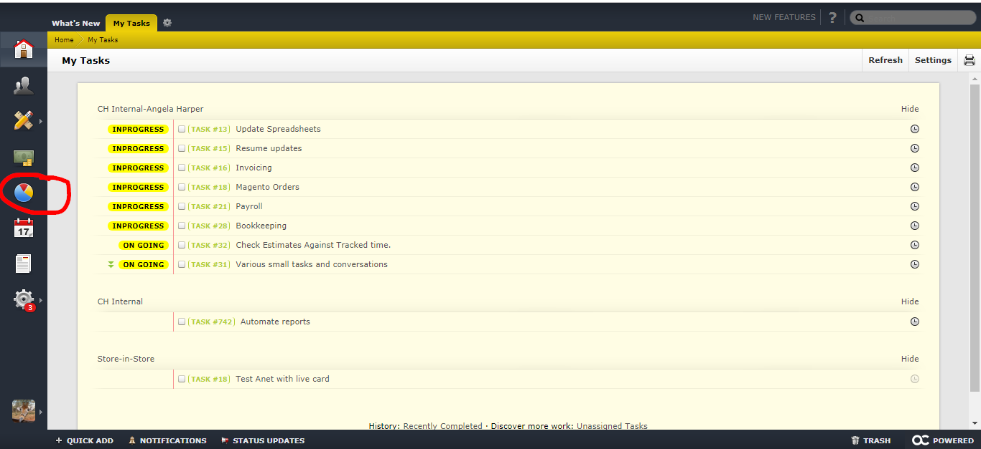

Select Assignments

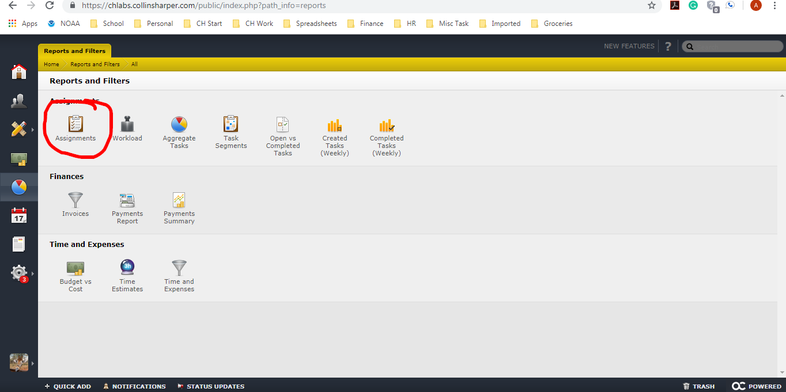

You will need to change 3 fields

Projects should read: Active Projects

Added Column #1 should read: Project

Added Colum #2 should read: Estimated Time

Also make sure that “Include Time and Include Subtask is checked.

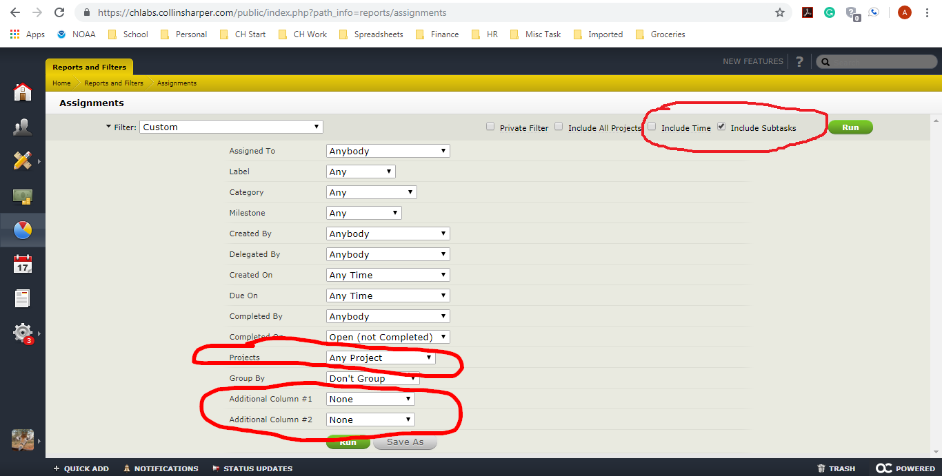

This is how it will look. There is a saved report called “Est. Vs. Actual”, I am just not sure if it is universally visible.

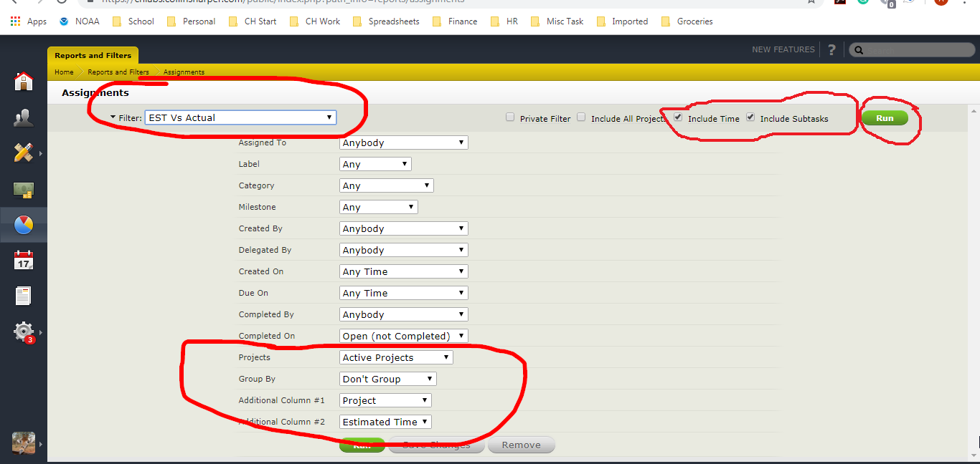

Click Run.

You will then get a screen like this. Scroll to the bottom.

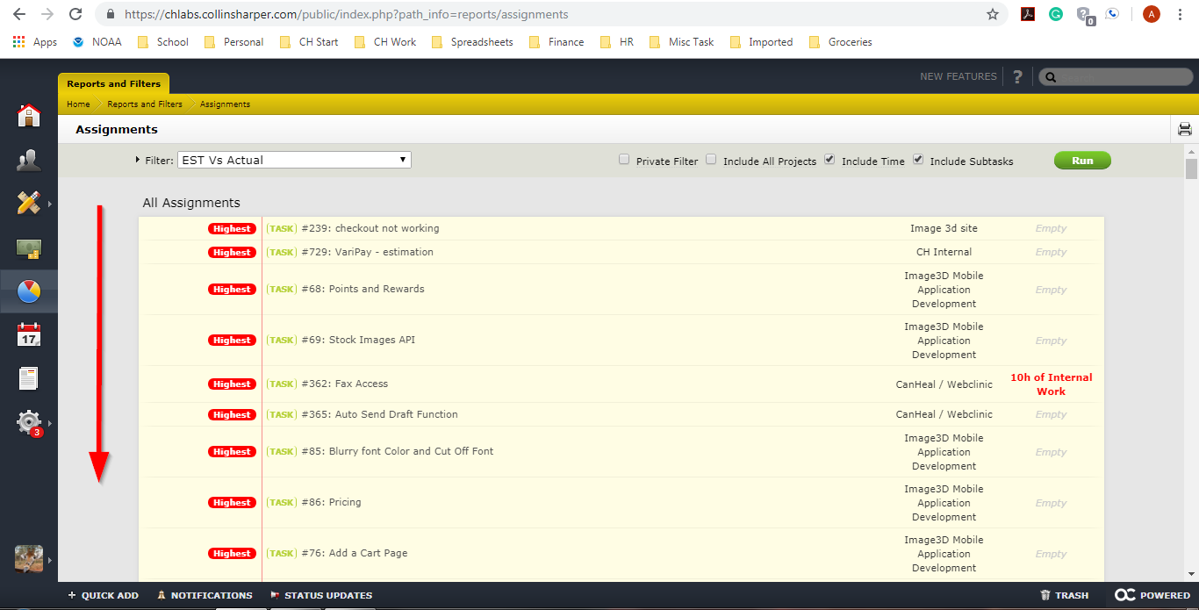

Select Excel.

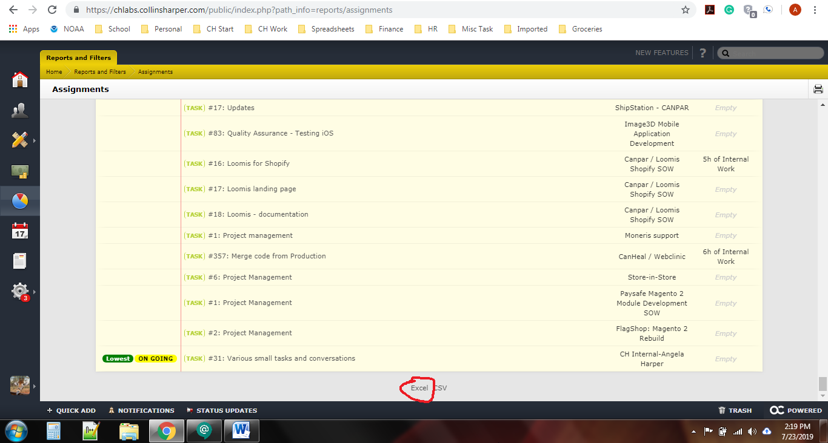

**Step Two**

Once the report opens most columns are deleted.

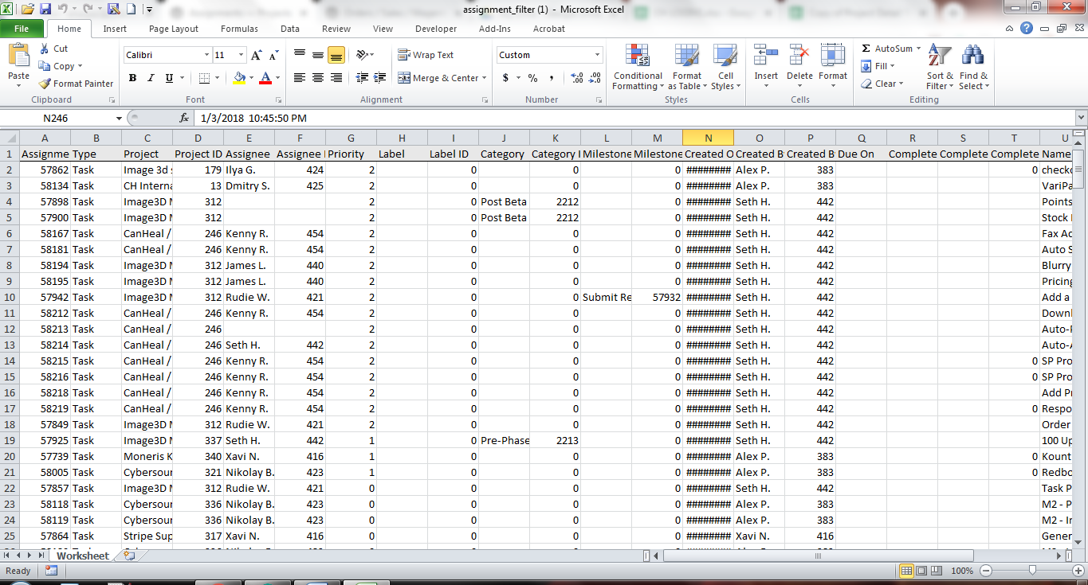

Delete Columns:

A

B

D thru T

V

X

Y

You should be left with:

“Project”

“Name”

“Estimated Time”

The columns then need to be rearranged to:

Name, Project, Estimated Time

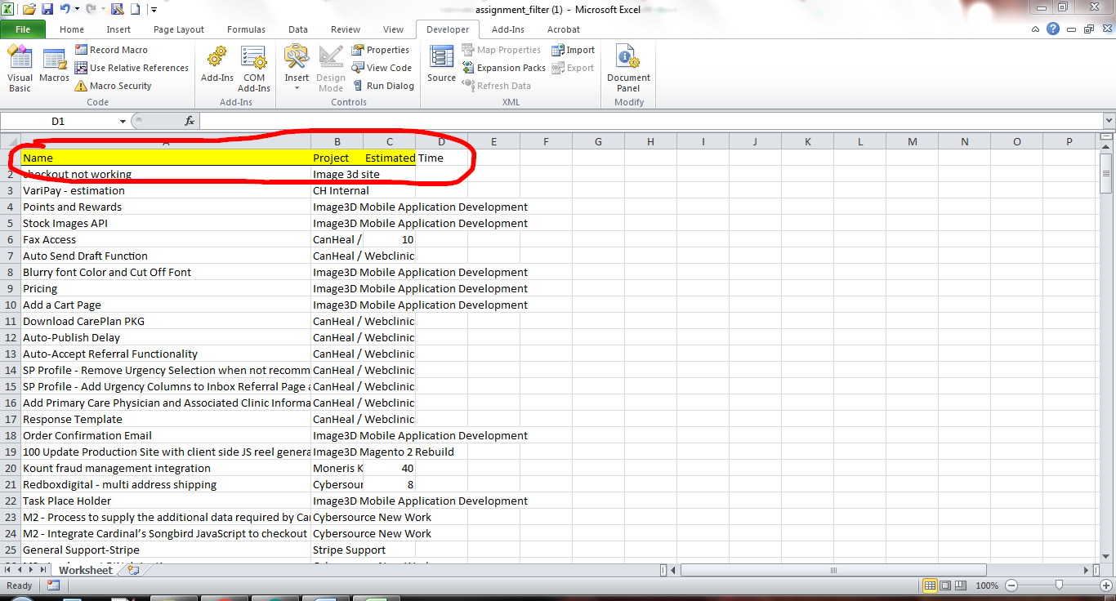

Step Four:

The sheet needs to be sorted A-Z By the Project Column.

Delete all Tasks for Project “CH Internal-Angela Harper”

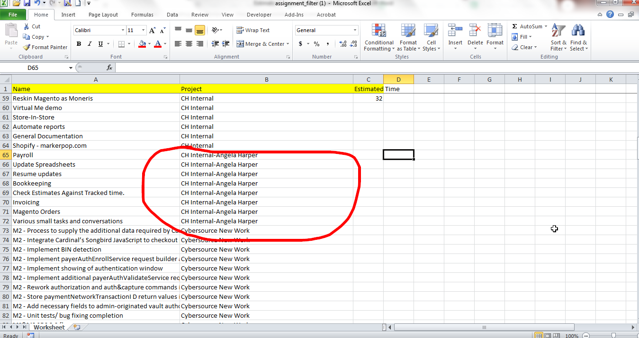

Next Sort Sheet by the Name column.

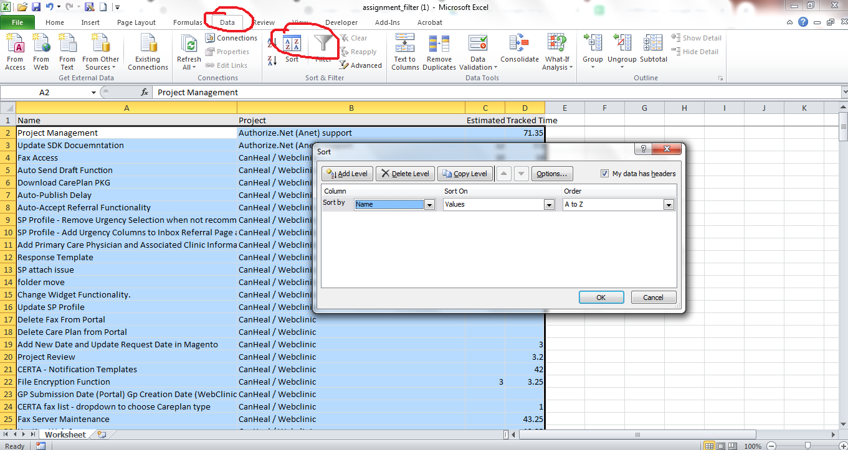

Next conditionally format only the “Name” (Column A) to highlight duplicates.

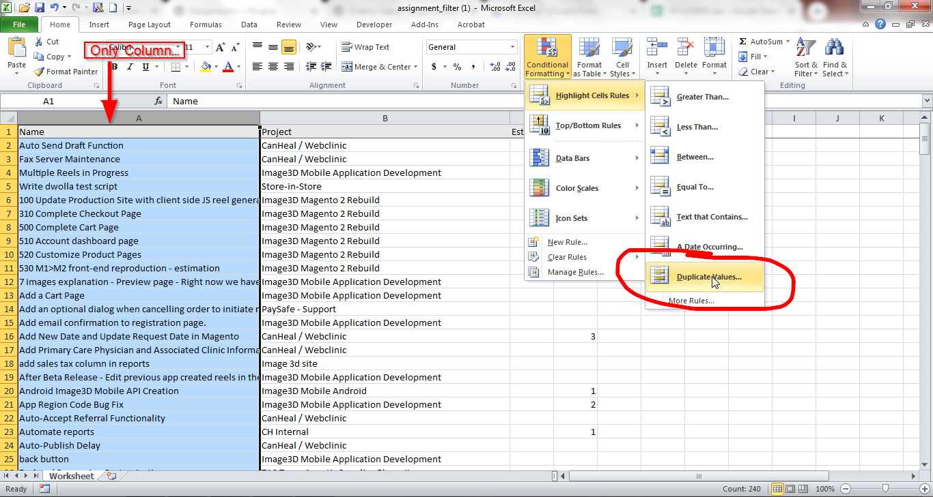

If there are duplicate names for different projects the duplicate name must be changed.

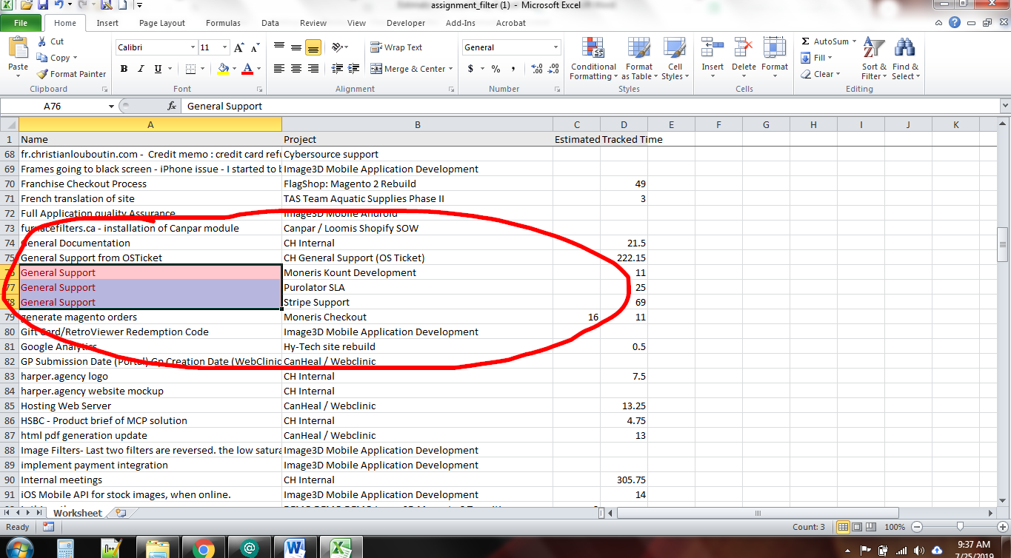

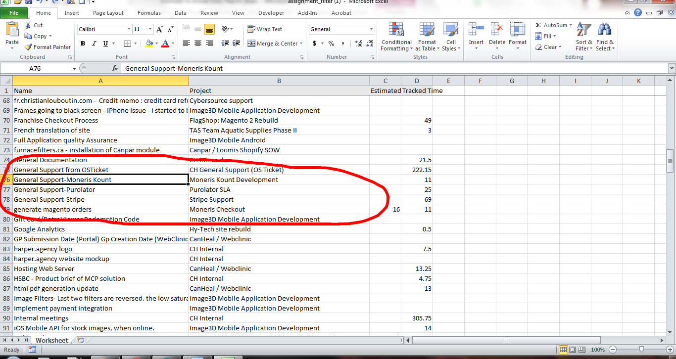

Next all “PM Activities” and “Project Management” Rows need to be deleted.

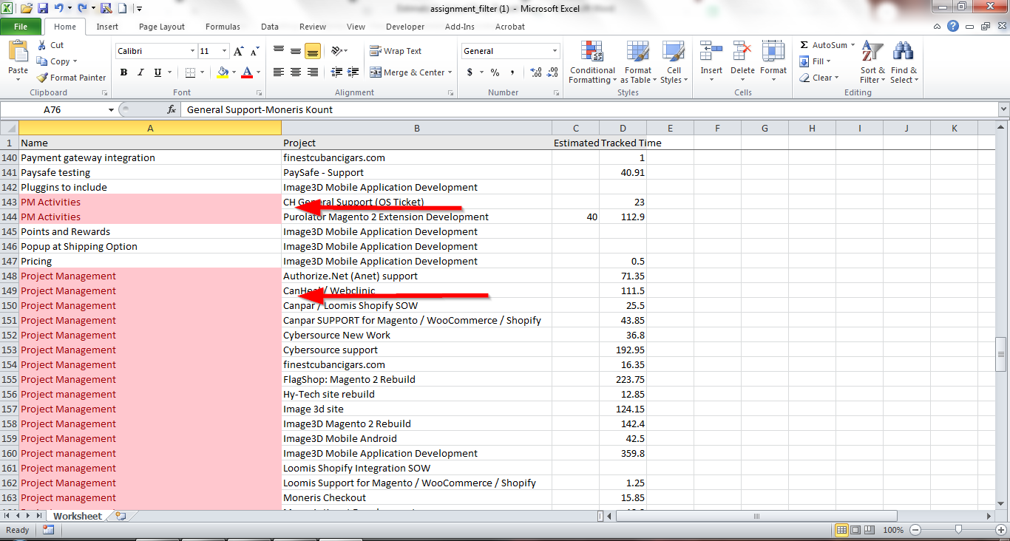

**Step Three**

The downloaded excel from labs now has to be compared to the “Project Detail Tracking” Sample document is located at: <https://docs.google.com/spreadsheets/d/1Msj3CmSd7BI9vxdqQ44vgKIBzdN7sBGa5CZfmtKkWpA/edit?usp=sharing>

A new sheet needs to be created on the download.

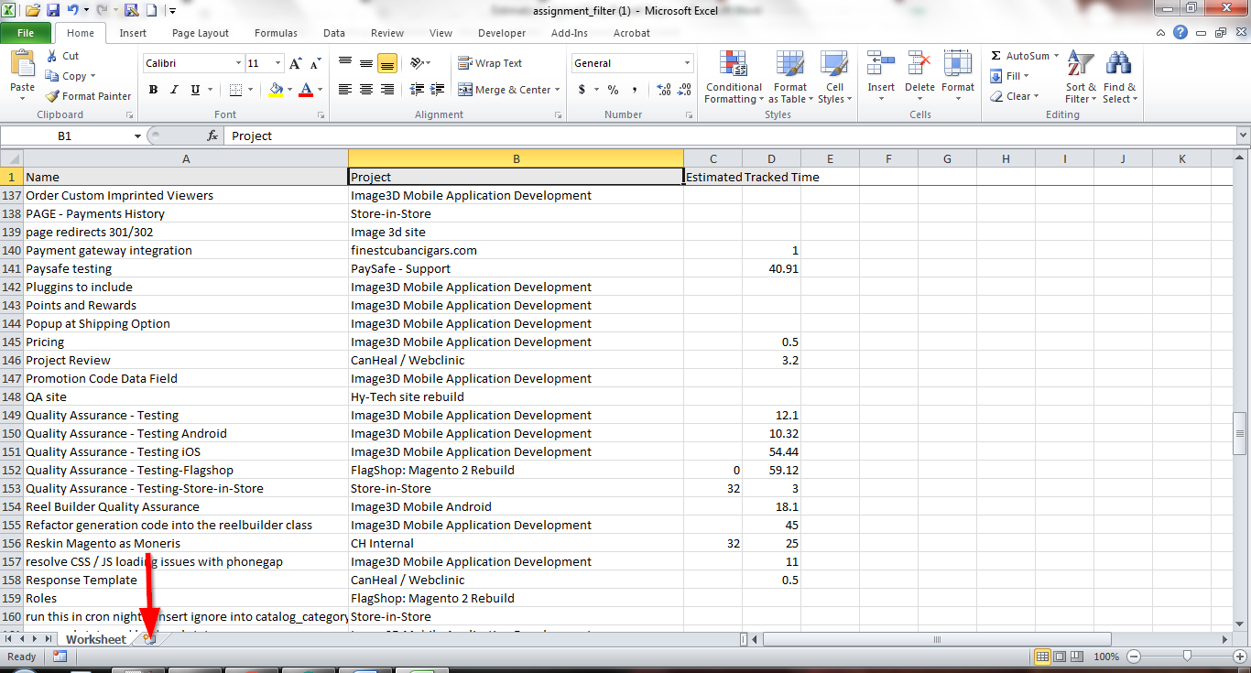

Open the Project Detail Tracking Sheet and go to the tab for current month’s task.

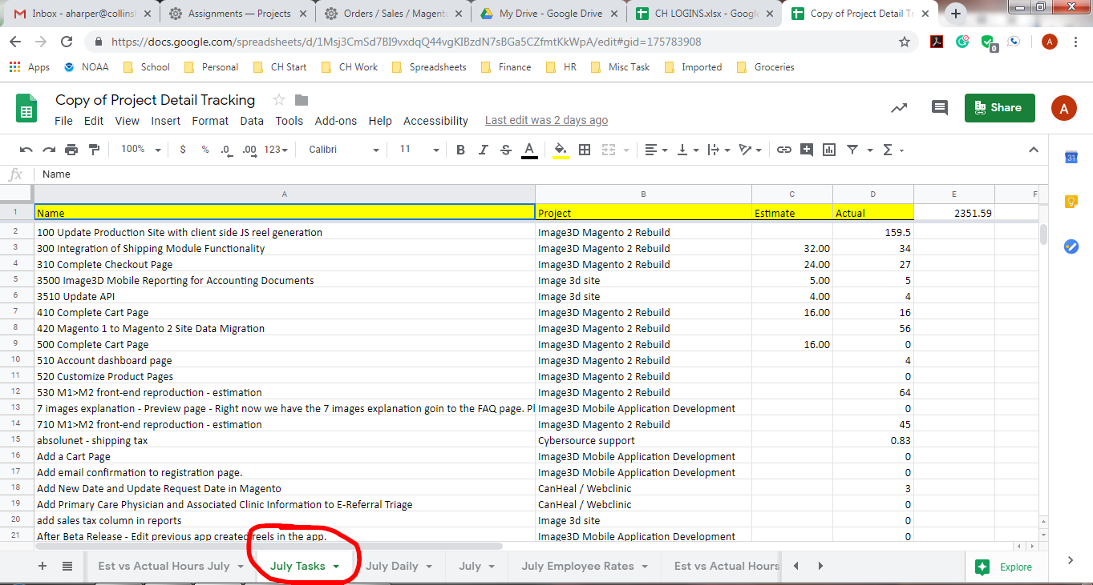

Click the square at the top of rows and left of columns to highlight the entire sheet.

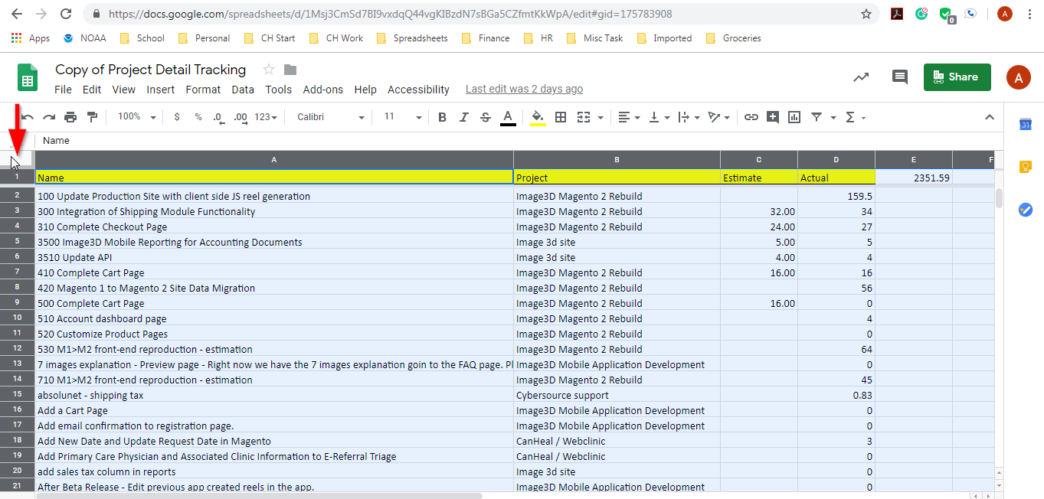

Now copy the entire sheet.

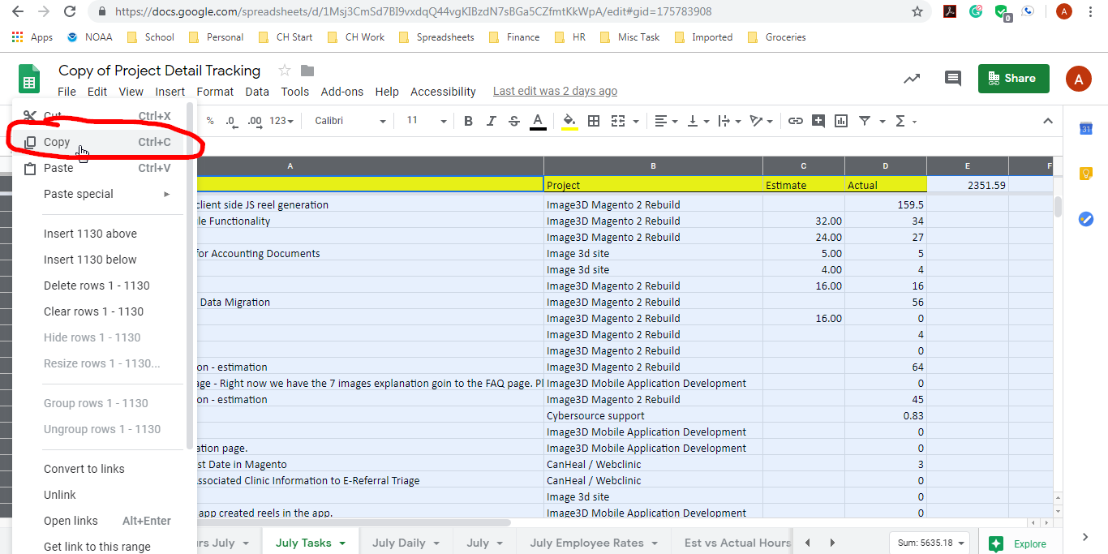

It now needs to be pasted on the new sheet in the downloaded excel.

Click the same square as the one used to copy from the tracker.

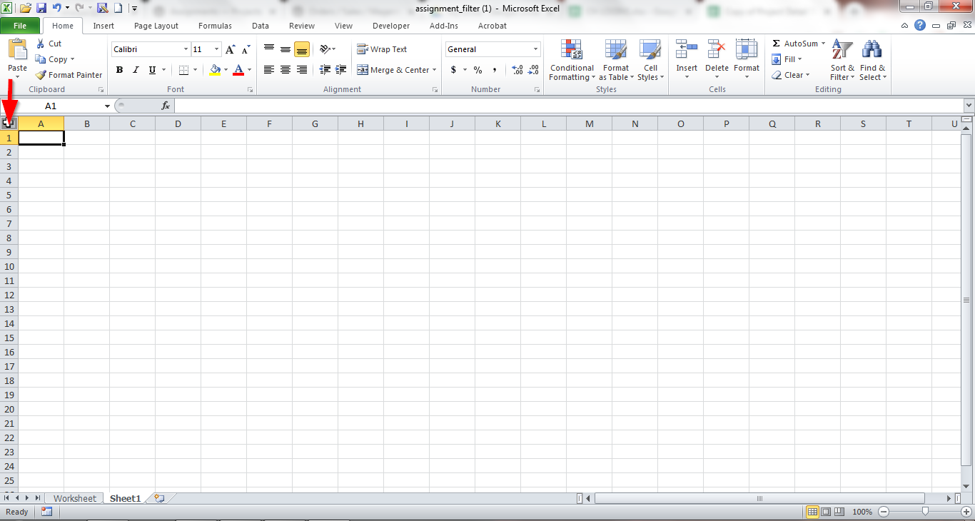

Click paste.

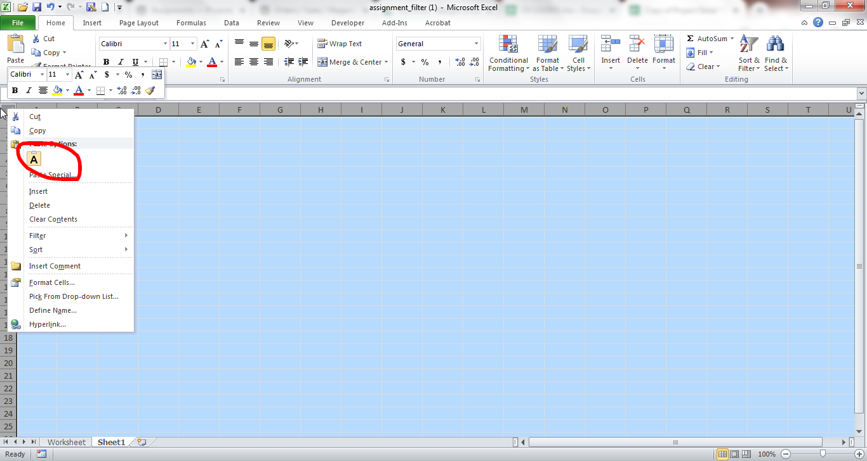

A warning will pop up. Click “OK”

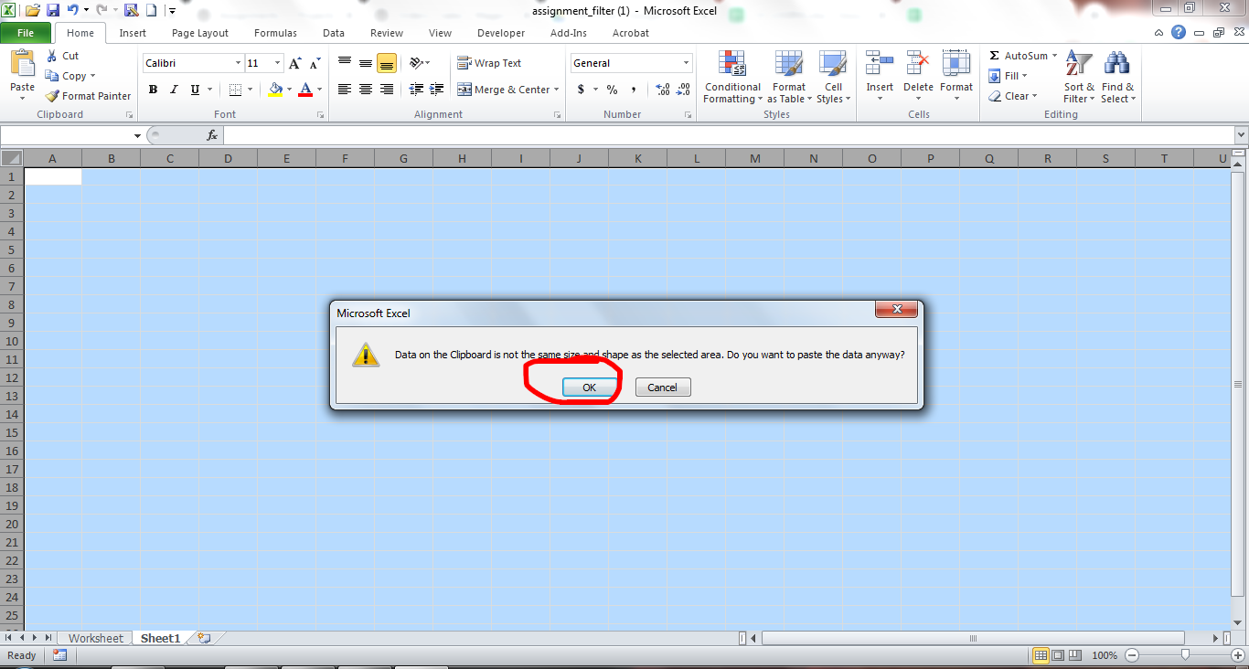

You now have this:

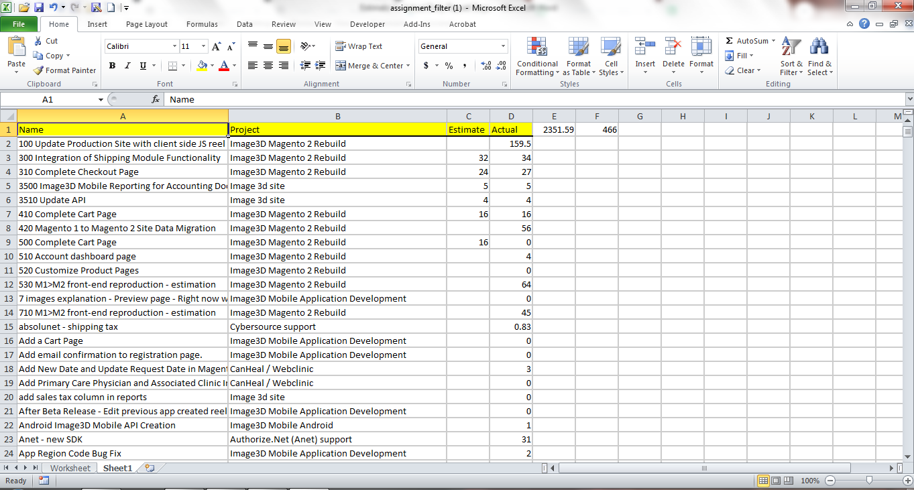

Sort the sheet by name:

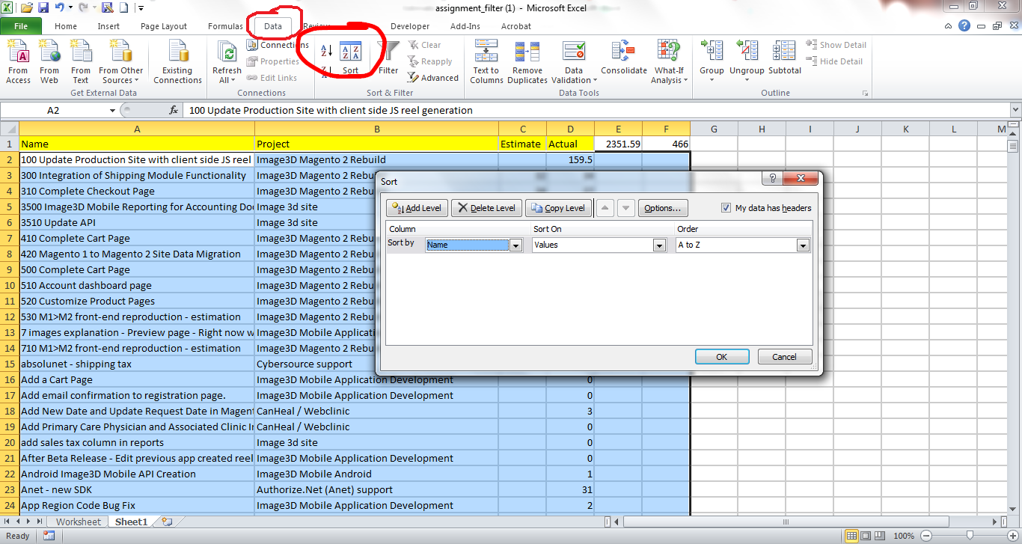

Another new sheet has to be created:

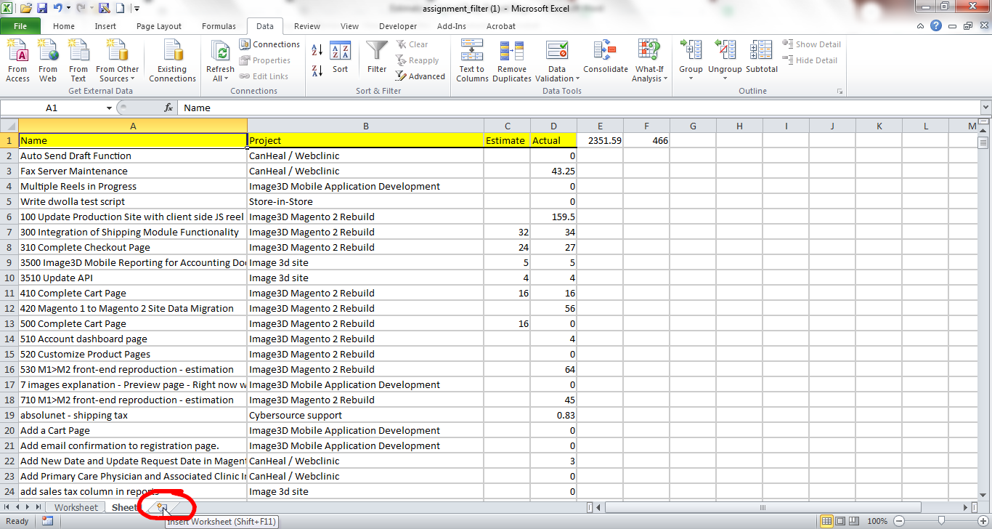

Copy row one from the sheet you just finished editing:

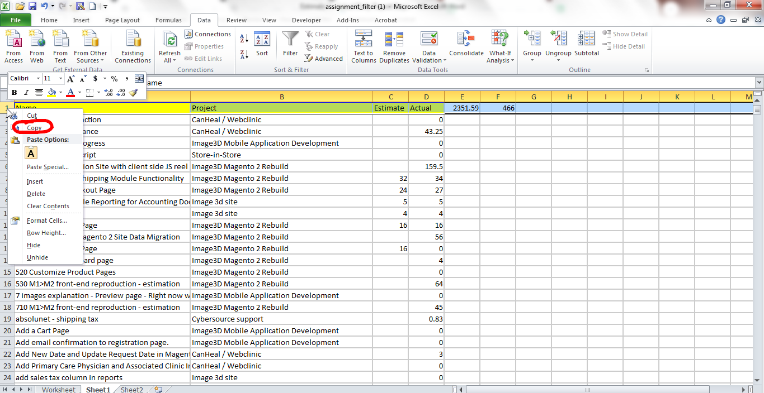

And paste it on the new sheet:

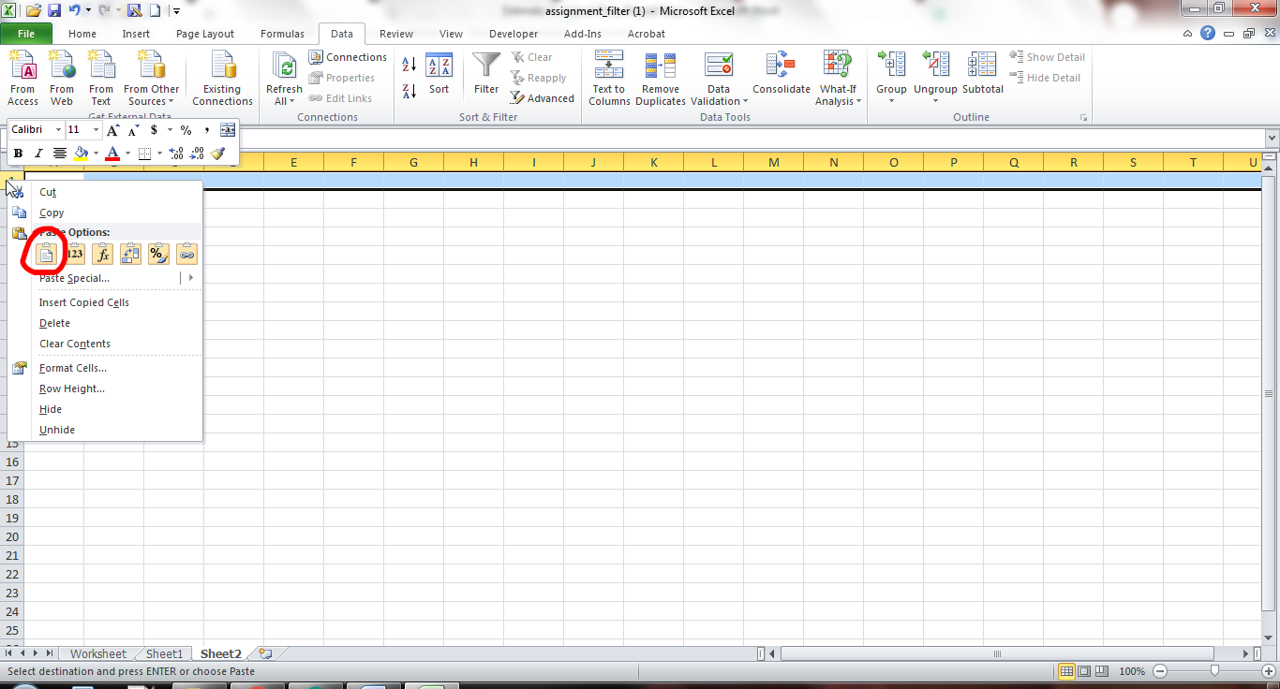

You now need to insert the formula: =Worksheet!A2=Sheet1!A2 in to cell A2 on the blank sheet

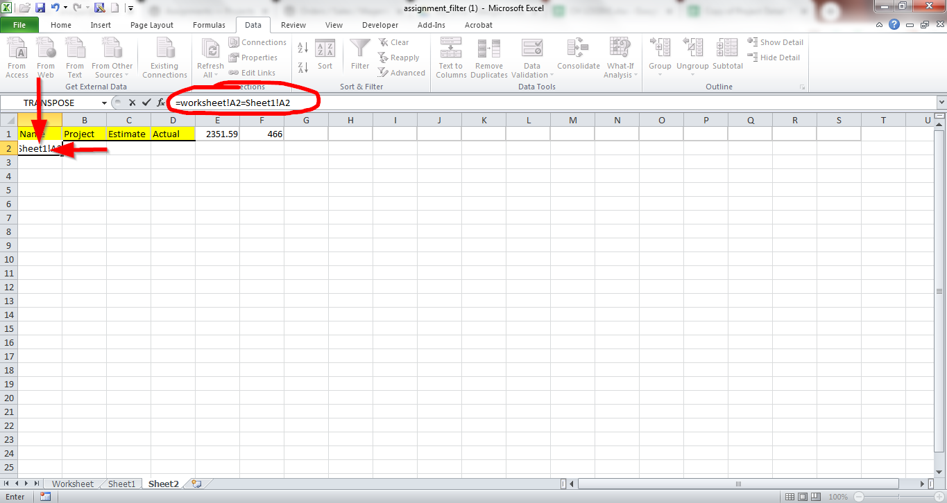

This will return a “True” or “False” Answer

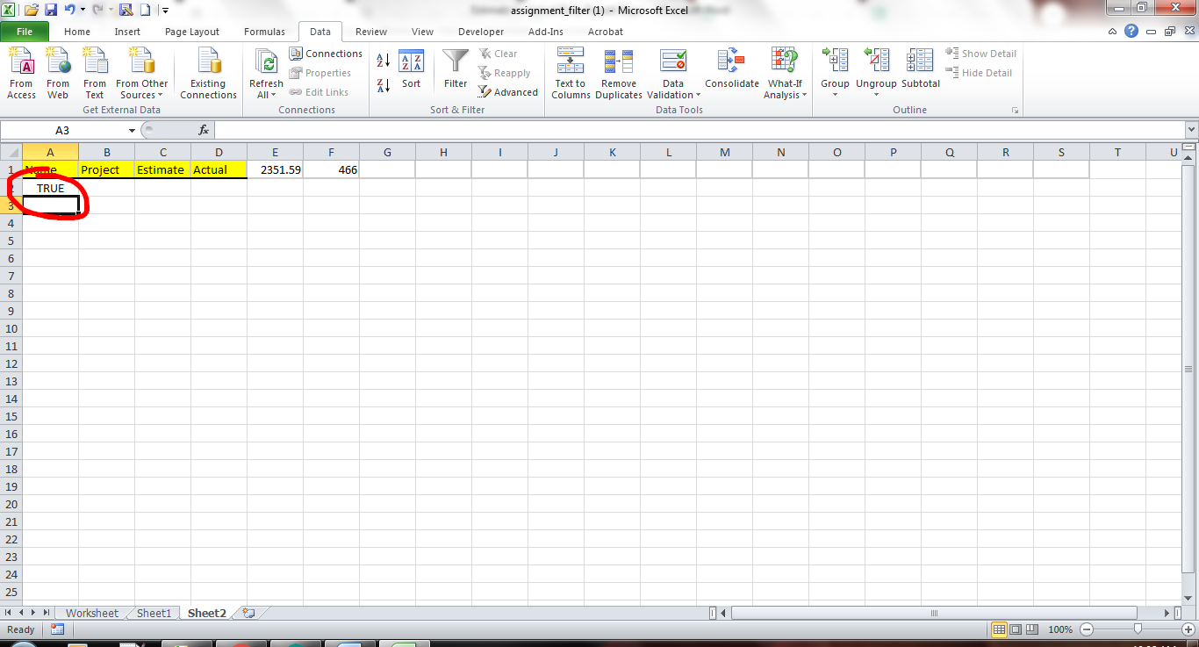

Grab the bottom of Cell A2 and drag it across the row to Estimate and then down the columns until you have gone to approximately 500

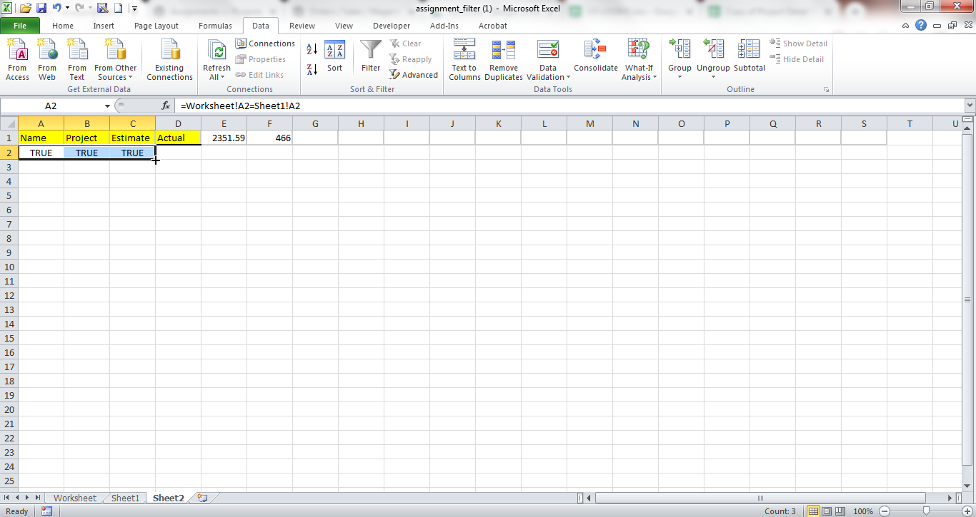

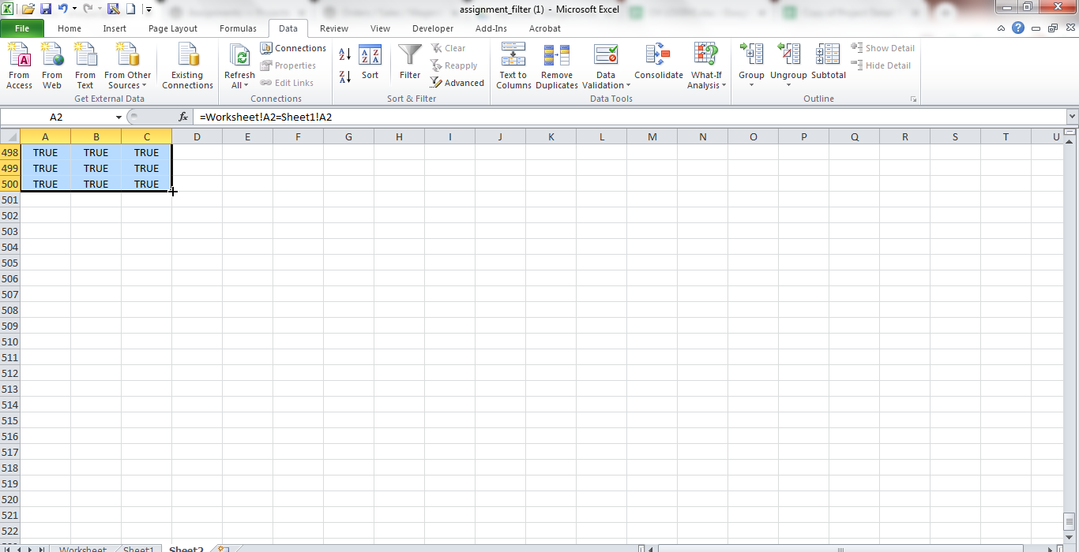

Now highlight all three columns and conditionally format for “Text that contains”

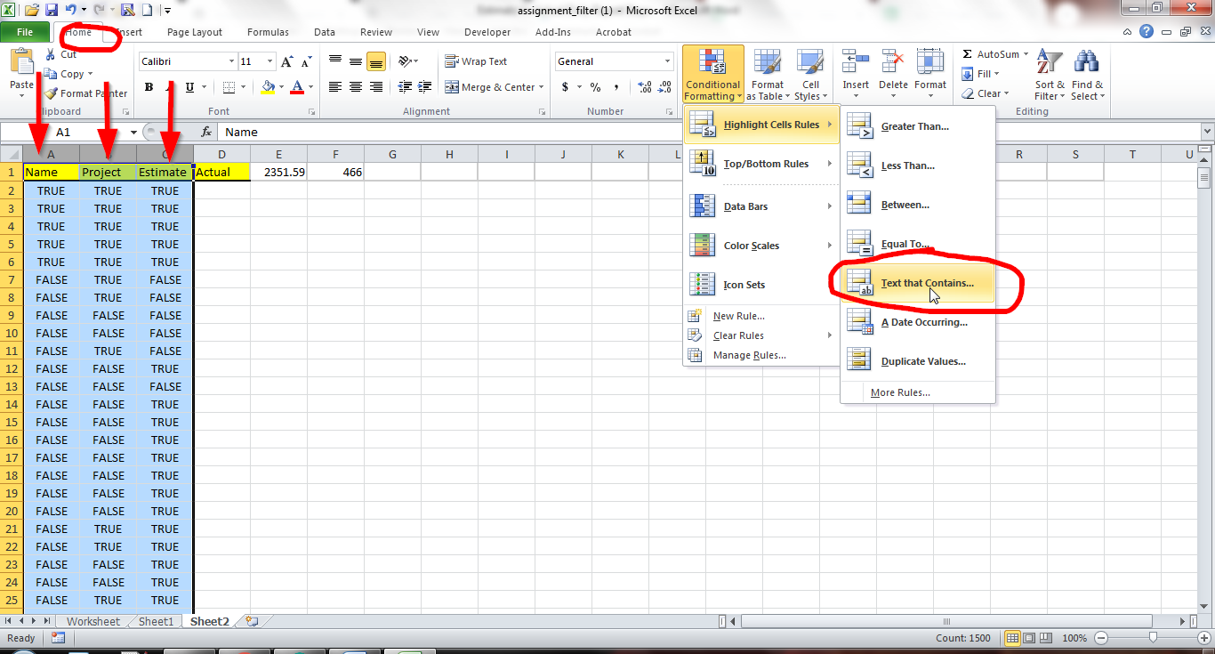

In the popup enter “FALSE”

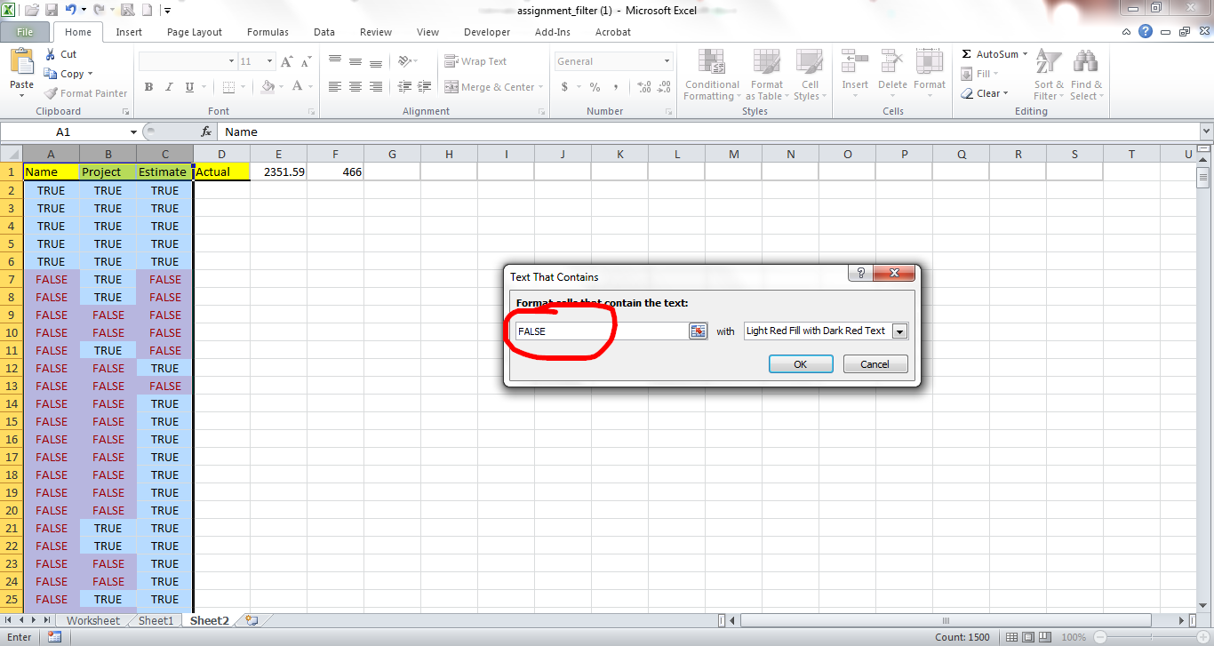

Everywhere there is a false the two other sheets need to be compared to find out why they do not match. There could be several reasons and each reason is handled differently.

**Reason One: New Task**

If the task on the “Worksheet” tab is not on the “Sheet1” tab it needs to be copied from “Worksheet” and inserted in to “Sheet1”.

Right click the row number to highlight the row and the select copy.

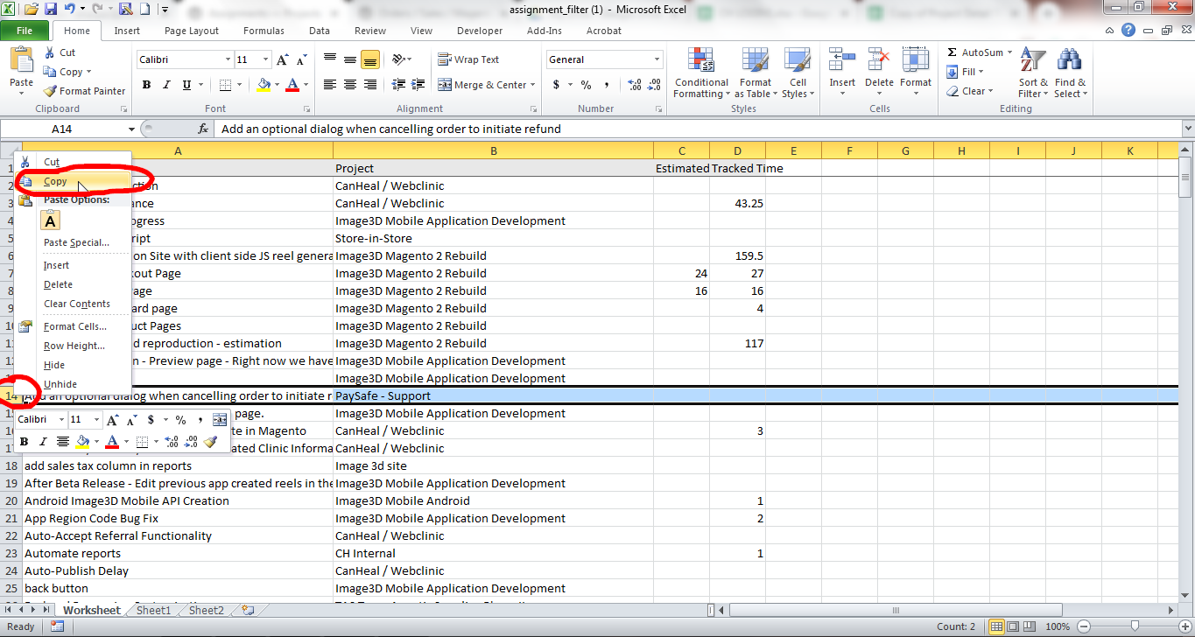

Next right click the same row number on “Sheet1” and select “Insert Copied Cells”

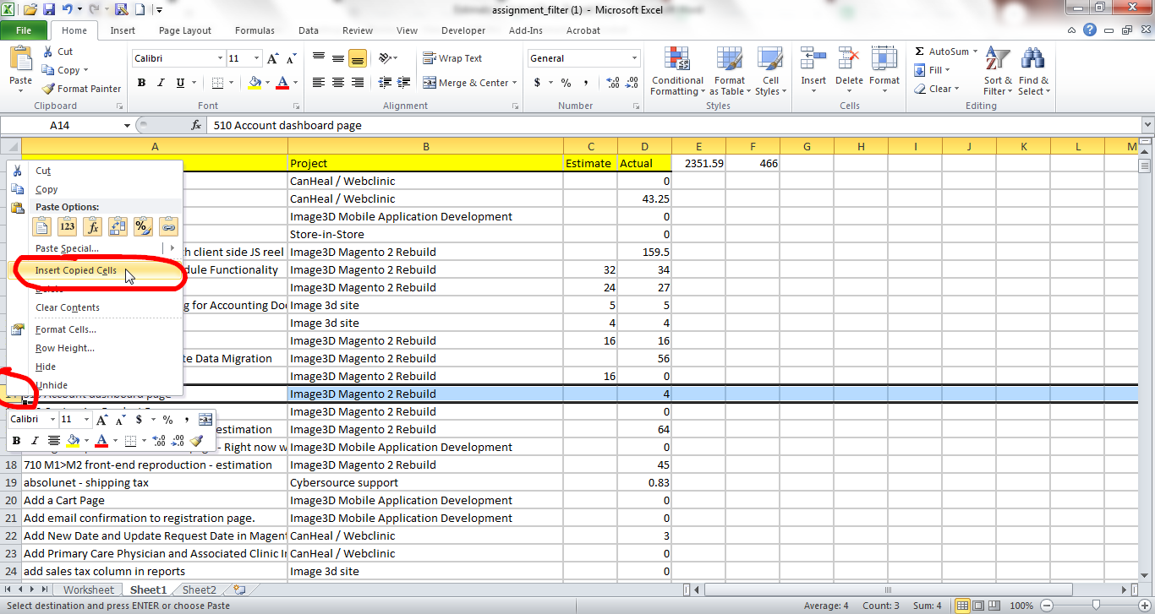

When you go back to “Sheet2” you will need to redo the formula. Since a row was inserted excel changed the formula for row 14 to the bottom of the sheet. So you need to go to row 13 cell A and re-drag the formula across and down.

**Reason Two: Task Completed**

If the task on the “Sheet1” tab is not on the “Worksheet” tab it is most likely a completed task. The task on “Sheet1” Needs to be looked at to see if there is any time on it. The task “300 Integration of Shipping Module Functionality” Is not on the “Worksheet” tab. Looking under the Actual column there is time reported. This means the task needs to be inserted onto the “Worksheet” Tab. Do this by following the steps above for coping and the inserting the copied cells. The again fix the formula in the cells as you did under the Reason One: New Task instructions above.

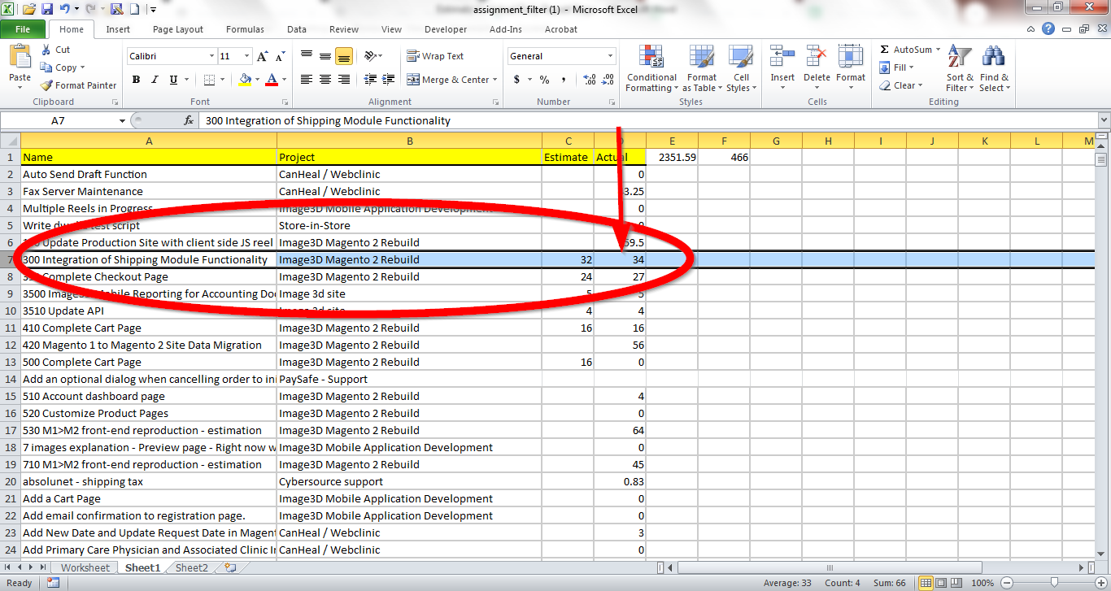

If there is no time showing, delete the row and then fix the formulas in the cells as described above.

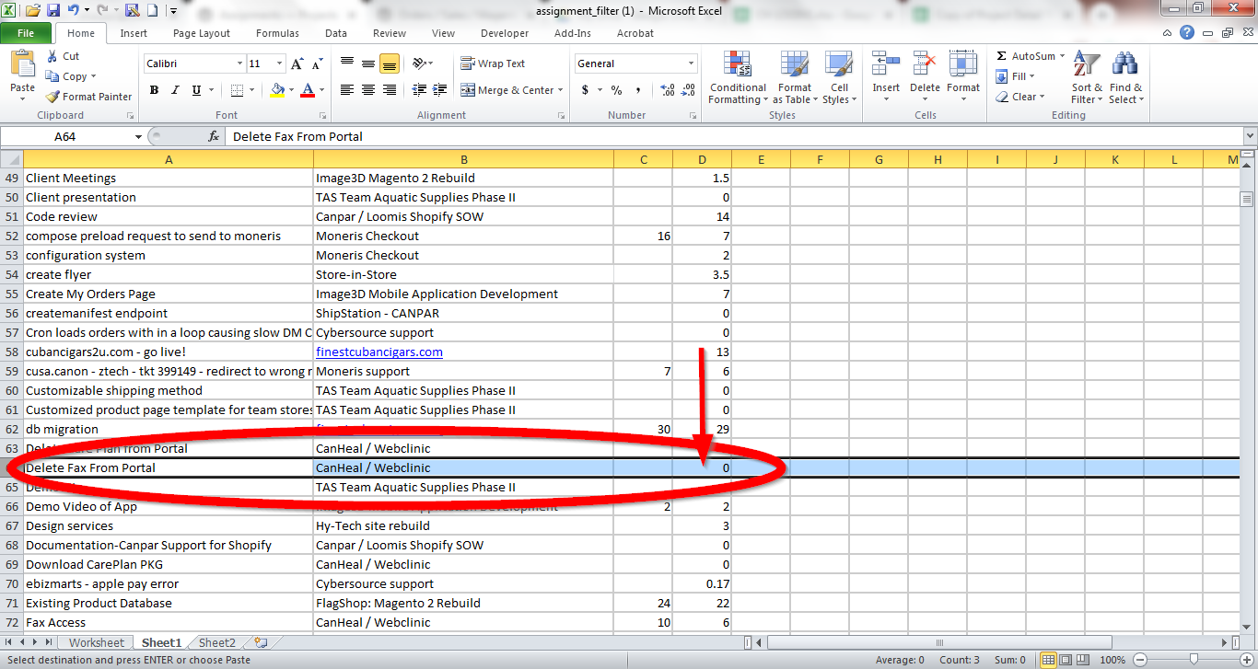

**Reason Three: Extra spaces or other format anomalies in name**

If you compare the “Worksheet” and “Sheet1” tabs and the two rows appear to match and you are still getting a false, you need to copy the cell from “Worksheet” and simple paste over the same cell on “Sheet1” You will not have to fix the formula in the “Sheet2” cell.

Example:

“Worksheet” shows:

7 images explanation - Preview page - Right now we have the 7 images explanation goin to the FAQ page. Please redirect to here: <https://www.image3d.com/retroviewer/7-images>

“Sheet1” shows:

7 images explanation - Preview page - Right now we have the 7 images explanation goin to the FAQ page. Please redirect to here: <https://www.image3d.com/retroviewer/7-images>

You cannot see a difference but excel does.

**Reason Four: Estimate Update**

If the only cell that is showing “False” is the Estimate Column all you need to do is copy the estimate times from the “Worksheet” tab and paste it in the same cell on the “Sheet1” tab. No cell formulas will need to be fixed.

**Step Four**

Once all the cells match the information has to be entered into the “Project Detail Tracking”

You will first need to delete all the cells that are currently on the “Task” Tab of the tracker; Making sure not to delete the equation column or the first row.

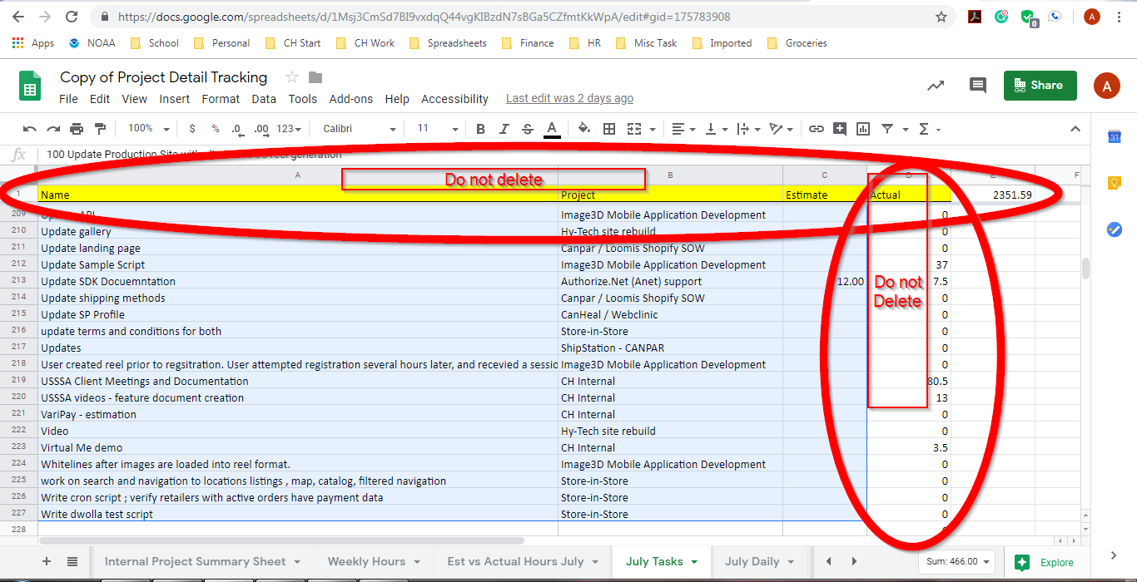

Once you have deleted the info you need to copy the “Worksheet” tab information by highlighting row 2 down for just the first 3 columns. Then you just paste it in to the current months Task Tab.

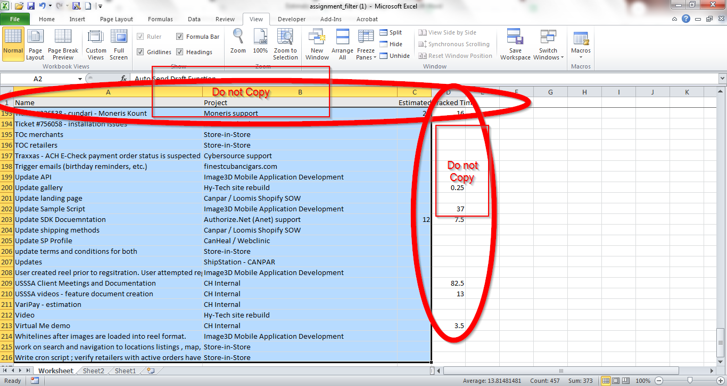

**Step Five**

The info you just pasted in the tracker needs to be copied onto another sheet in the tracker.

Go to the “Est. vs Actual Hours” tab for the current month.

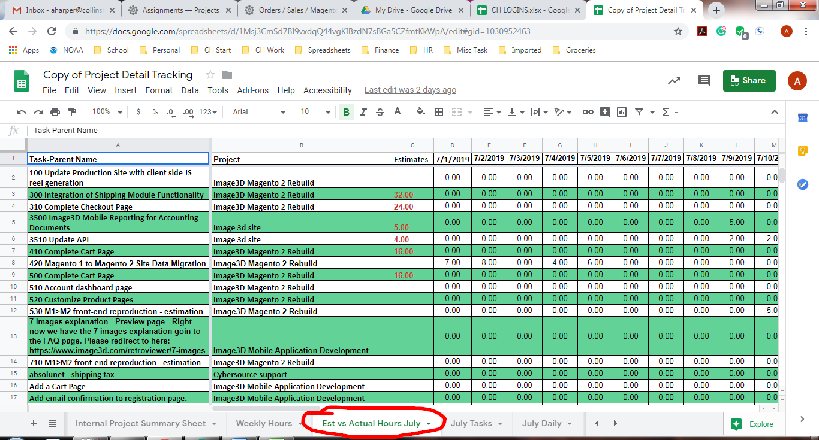

You will need to delete the information from columns A,B, and C from row two downward.

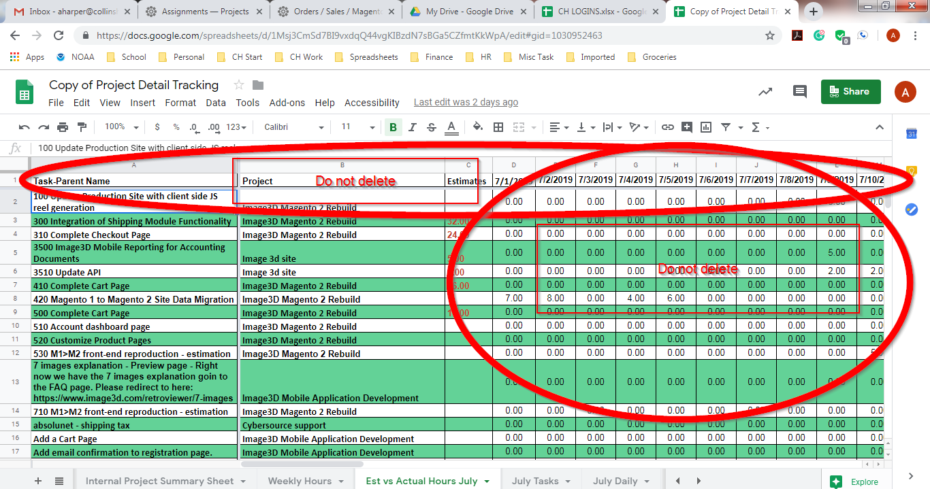

Now return to the “Task” tab and copy columns A,B and C from row 2 down.



On the “Est. vs Actual Hours” tab “Paste Special: Paste Values Only”

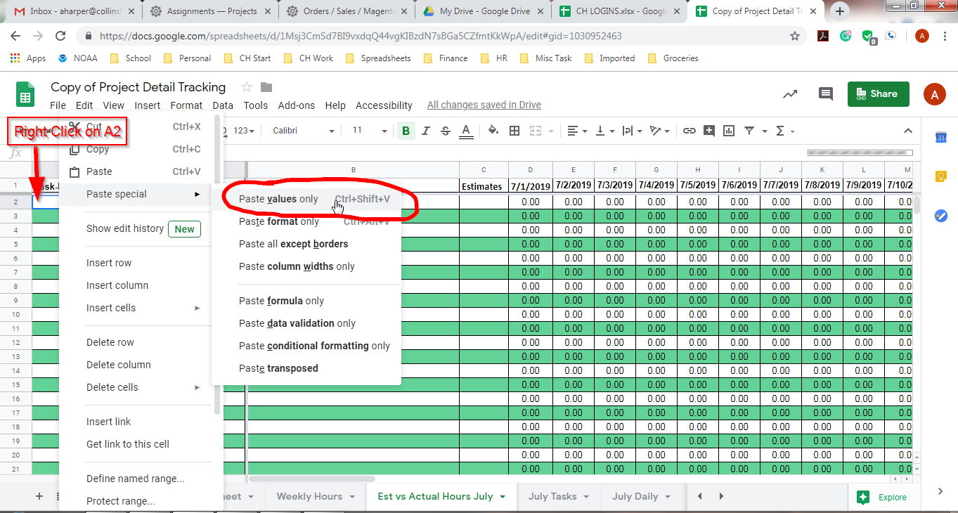

**Step Six**

You now need to verify all information is correct.

On the “Est. vs Actual Hours” tab far over on the right are several verification equations.

If the equations show “True” you are done. If they show “False” you will need to check why.

